**Common Rice Diseases and Their Management**

**Bacterial Diseases**

**Bacterial Leaf Blight (*Xanthomonas oryzae* pv. *oryzae*)**

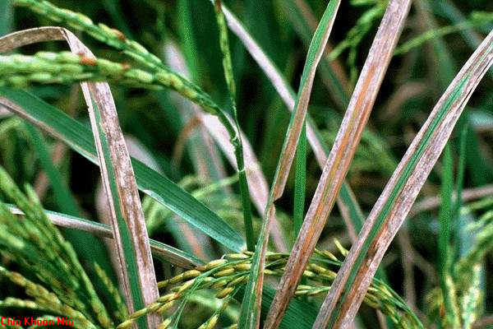

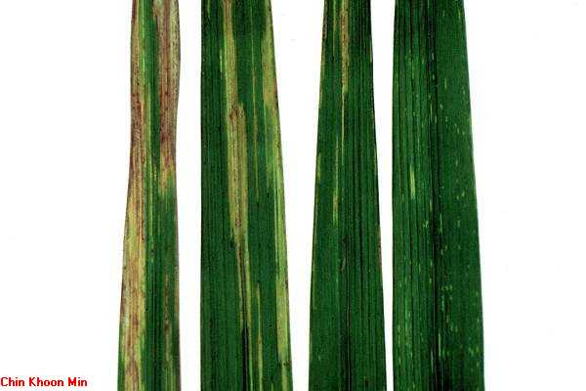

**Symptoms**

* first appear as water-soaked stripes at the margin of fully developed leaves
* lesions enlarge both in length and width. Margins are wavy and turn light brown in a few days
* regions adjoining the healthy part has a water-soaked appearance
* lesions may start at one or both edges of the leaves and as the disease advances, the lesions cover the entire blade, turn grayish, and later white
* appearance of milky or ”opaque dew drops” on the surface of young lesions in the morning is a **sign** of bacterial blight infection
* the milky dew drops dry to form small, amber-colored beads and these spheres are the ooze of the bacterial mass
* infection at seedling stage develop “Kresek” or wilting of whole leaves or the entire plant
  + usually caused by the bacterial invasion of roots injured during transplanting and through cut-ends of leaves
  + observed from two to four weeks after transplanting

**Disease Management**

* no bacteriocides are effective against bacterial blight
* resistant varieties are the most economical and effective means to control bacterial blight
* because of new virulent races, integrated approach may be more appropriate
  + use of resistant varieties together with modified cultural practices to disrupt the disease cycle and proper deployment of resistant varieties in the field

**Bacterial Leaf Streak (*Xanthomonas oryzae* pv. *oryzicola*)**

**Symptoms**

* lesions start as small translucent streaks and enlarge lengthwise and may advance laterally over the larger veins
* lesions often coalesce and form large, brown lesions which cause severe damage on susceptible varieties
* at later stages of disease development, entire leaves turn brown, and eventually die

**Disease management**

* The use of resistant varieties is the most economical and practical method of controlling this disease in the tropics.

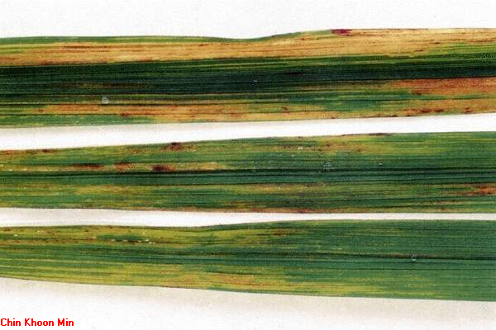

* 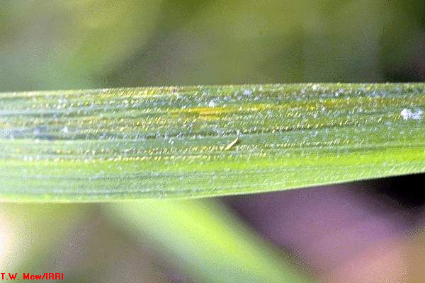

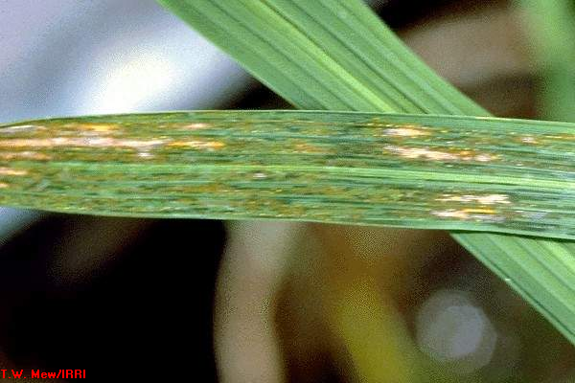

**Fungal Diseases**

**RICE BLAST – *Magnaporthe grisea (Piricularia oryzae)***

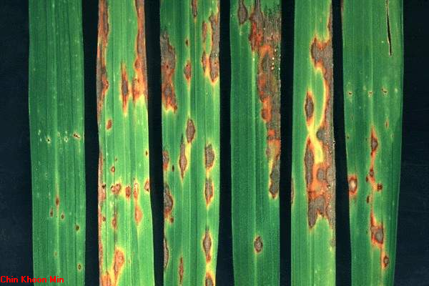

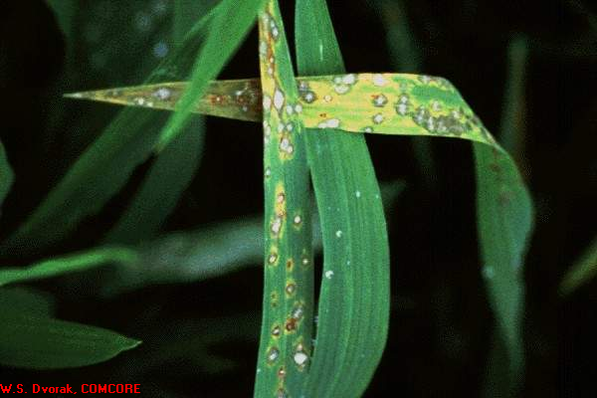

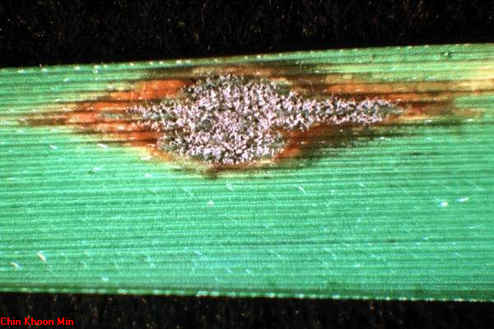

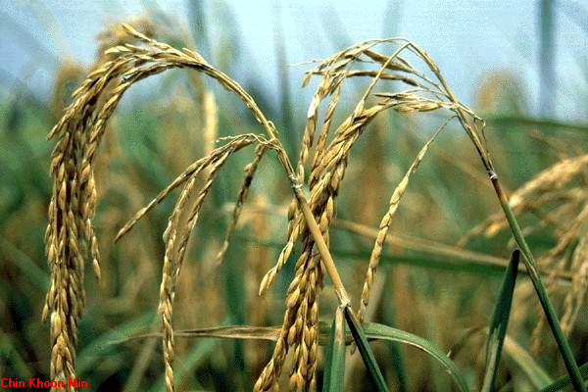

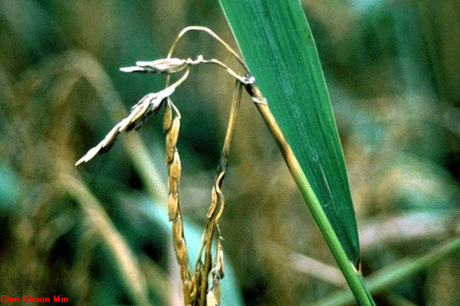

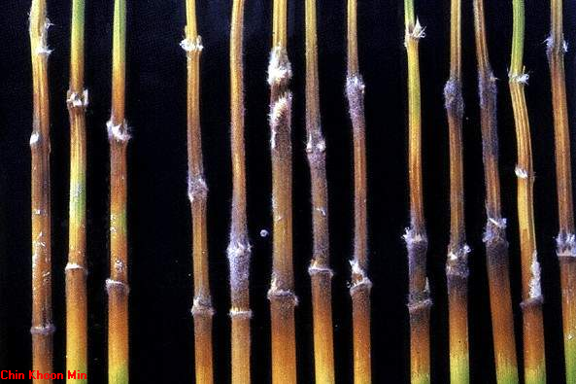

**Symptoms**

* on the leaves (usually during the seedling stage), the spots are spindle shaped, pointed at both ends, often showing a brownish margin
  + size, color and shape of spots vary with conditions and varietal resistance
* causes the most serious damage when it attacks the neck of the panicles
  + lesions are often found near the uppermost node. Grayish-brown lesions are formed and the neck is girdled, causing the head or panicle to fall over
* the disease may also attack the nodes of the culm. Affected nodes become black and brittle and the culm may break at the nodes

**Disease management**

* The use of resistant varieties is the most economical and practical method of controlling the disease.
* It is advisable to raise seedlings in lowland conditions because it has been observed that seedlings raised in upland nurseries are more susceptible to blast even after transplanting
* Reduce nitrogenous fertilizer application to prevent severe outbreak of blast in susceptible varieties
* Several recommended fungicides are available against rice blast

**SHEATH BLIGHT (*Rhizoctonia solani*)**

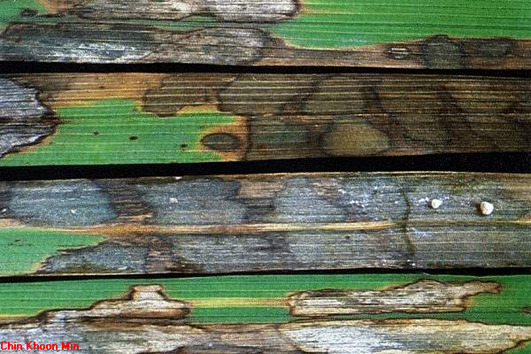

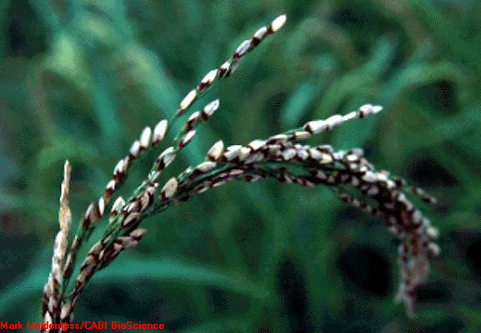

* common on both lowland and upland rice fields

* the fungus attacks plants at different growth stages but is more distinct at pre-booting stage

**Symptoms**

* characterized by the presence of large spots confined mostly to the leaf sheaths. Spots occur occasionally on the leaves and stems
* in paddy fields, the spots usually occur above the water line and quite frequently just below the ligule
* spots are at first greenish-gray and ellipsoid which quickly enlarge and become grayish with blackish-brown margins
  + lesions may coalesce to form irregular discolored areas
* in severe cases, the leaf sheaths are entirely rotted
* sclerotial bodies (compact masses of hardened mycelia) on the infected parts are irregular in shape

**Disease management**

* Good water management help minimize sheath blight
* Several recommended fungicides are available against sheath blight
* None of the 65,000 varieties and breeding lines tested at IRRI was found highly resistant to sheath blight .
* Majority of the cultivars have intermediate and susceptible reaction to the disease
* Deep plowing to bury and submerge infected stubbles and sclerotia helps reduce sources of inoculum

**BROWN SPOT or HELMINTHOSPORIUM LEAF SPOT**

**(*Helminthosporium oryzae*)**

***(Cochliobolus miyabeanus*)**

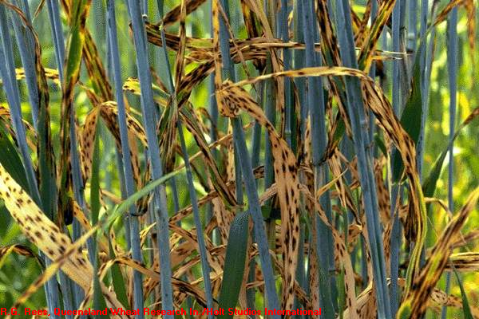

* the fungus is seed borne
* attacks rice plants at all stages of development
* occurs in all major rice-producing countries
* serious when plants are heavily shaded, when soil is deficient in potash, and when rice is grown in saline soil

**Symptoms**

* on leaves, the spots vary in size and shape from minute dots to circular or oval spots
  + smaller spots are dark brown or purplish brown. Larger ones have the same color at the edge but maybe pale yellow, dirty white, brown or gray towards the center
  + spots may coalesce so that the entire leaf surface withers and dries up
* symptoms on the leaf sheaths are similar to those on the leaf

**Disease management**

* Plant resistant varieties
* Use only healthy or clean seeds for planting or treat seeds with recommended fungicides if necessary
* Apply muriate of potash to correct the soil deficiency
* Spray with recommended fungicides

**CERCOSPORA LEAF SPOT or NARROW LEAF SPOT (*Cercospora oryzae*)**

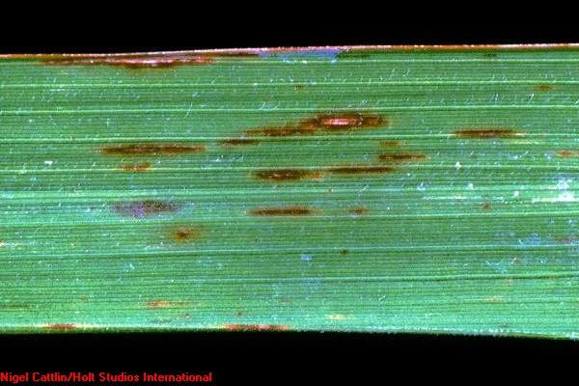

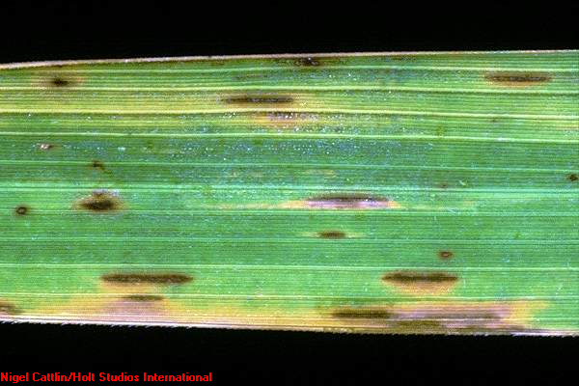

**Symptoms**

* lesions are linear, 3 to 5 mm in length, about 1 to 1.5 mm in width along the leaf axis
* center of the spot is dark brown, the border fading toward the outer margin of the spot
* sheath lesions are the same as those on the leaf or may be longer
* in resistant varieties, the lesions are uniformly red-brown throughout and very narrow; in susceptible varieties the spots are wider with a narrow light-brown or gray-brown center

**Disease management**

* Plant resistant varieties in areas where the disease is severe

**SHEATH ROT (*Sarocladium oryzae)***

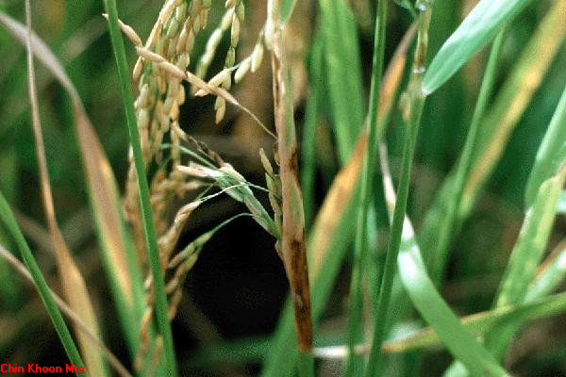

**Symptoms**

* Infection occurs on the uppermost leaf sheath at late booting stage.
* Severe infection may cause panicles to be only partially exserted are rotted and show abundant powdery fungus growth inside the leaf sheath.
* Partially emerged panicles may produce poorly filled grains.

**BAKANAE (*Fusarium moniliforme*) (*Gibberella fujikuroi*)**

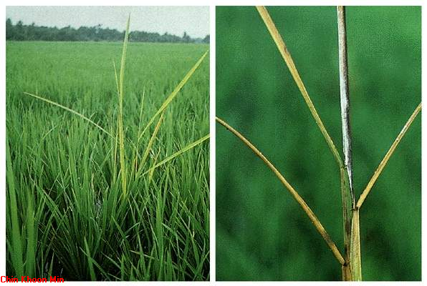

**Symptoms**

* **infected seedlings are easily identified in the field because they are relatively taller, spindly and pale compared to the healthy seedlings**
* **at later stage infected plants become yellow and begin to wilt**
* **mycelia present on the nodes of infected plants are signs of the pathogen**

**Disease management**

* **Plant resistant varieties**
* **Seed treatment with recommended fungicides**
* **Gather and burn infected plants or deep plowing to bury and submerge infected stubbles can help reduce sources of inocula**

**VIRAL DISEASES**

**Tungro Rice tungro bacilliform virus (RTBV) and Rice tungro spherical virus (RTSV)**

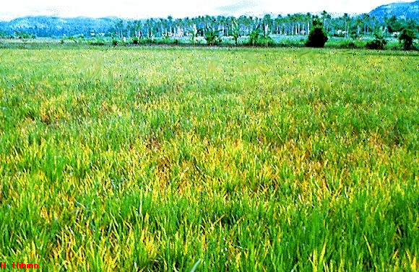

* + **Transmitted in a semi-persistent manner by species of green leafhopper, the *Nephottetix virescens* is the most efficient vector.**
  + **Not transmitted mechanically and not seed transmitted**

**Tungro symptoms**

RTBV alone: Yellowing and stunting

RTSV alone: No yellowing, very mild stunting

RTBV and RTSV: Severe yellowing and severe stunting

**Tungro Management**

**Cultural measures to eradicate virus sources and reduce the population of insect vectors**

* Synchronized planting with distinct fallow period between cropping
* Avoidance of late plantings
* Roguing but effective only under low disease

**Tungro Management**

**Use of resistant varieties**

* Virus resistant
* Vector resistant
* Tolerant varieties

At present, prevention of tungro is the most logical means of control. This can be done by:

1. Planting resistant varieties

This is considered the most practical and economical means of managing tungro.

1. Destruction of stubbles several days after harvest by plowing and harrowing to eradicate GLH and possible source of tungro viruses
2. Avoid planting late (more than a month after most fields in the area are planted). Most of the GLH from the adjacent or nearby fields with older plants will migrate to the newly planted field because GLH prefer younger rice plants.
3. Observe neighboring fields for presence of tungro and know the variety planted to anticipate future actions.
4. Avoid planting susceptible varieties in areas where tungro occur in almost all rice varieties
5. Use insecticides only when needed to save money and the friendly (beneficial) insects. Generally, no insecticide protection is needed in plants more than 60 days old after transplanting, and when no tungro and few GLH are present

Problems in tungro management

1. The absence of symptoms at early stage of disease development. The farmers often notice the presence of tungro in their fields only when the plants show symptoms of yellowing and stunting. At this stage, another generation of GLH had developed, more eggs were laid and the disease had already spread making control more difficult
2. “Vector adaptation” on GLH- resistant variety. The time when GLH adapts on resistant variery is difficult to know. It is greatly influenced by number and length of time GLH colonized the variety. Although insect resistant varieties can slow the progress of the disease spread, their continuous use for several seasons is not recommended

References:

Bayot Rizaldo G. Bayot. Common Rice Diseases and Their Management Lecture

Crop Protection Compendium 2005 Edition. CAB International.